**Assignment 6 Write up**

**UML Diagrams**

|  |
| --- |
| AlcoholTest |
| +a1:Alcohol  +a2:Alcohol  +a3:Alcohol  +a4:Alcohol |
| + setUp(): void  + tearDown():void  +testGetBasePrice():void  +testCalPrice():void  +testToString():void |

|  |
| --- |
| CoffeeTest |
| +c1: Coffee  +c2: Coffee  +c3: Coffee  +c4:Coffee |
| + tearDown():void  +testGetBasePrice():void  +testCalPrice():void  +testToString():void |

|  |
| --- |
| OrderTestGFA |
| +r1:Order  +r2: Order  +r3: Order  +r4: Order |
| + tearDown():void  +testGetBevarage():void  +testAddNewBeverage():void  +testCalcOrderTotal():void |

|  |
| --- |
| CustomerTest |
| +c1:Customer  +c2:Customer |
| + setUp(): void  + tearDown():void  +testConstructor():void |

|  |
| --- |
| BevShopTest |
| +bevshop: BevShop |
| + setUp(): void  + tearDown():void  +testValidTime():void  +testValidAge():void  +testStartNewOrder():void  +testProcessAlcoholOrder():void  +testProcessSmoothieOrder():void  + testProcessCoffeeOrder():void  + testFindOrder():void  + testTotalOrderPrice():void  + testTotalMonthlySale():void  + testSortOrders():void  + testToString():void |

|  |
| --- |
| SmoothieTest |
| +s1:Smoothie  +s2:Smoothie  +s3:Smoothie  +s4:Smoothie |
| + setUp(): void  + tearDown():void  +testGetBasePrice():void  +testCalPrice():void  +testToString():void |

**Screenshot**

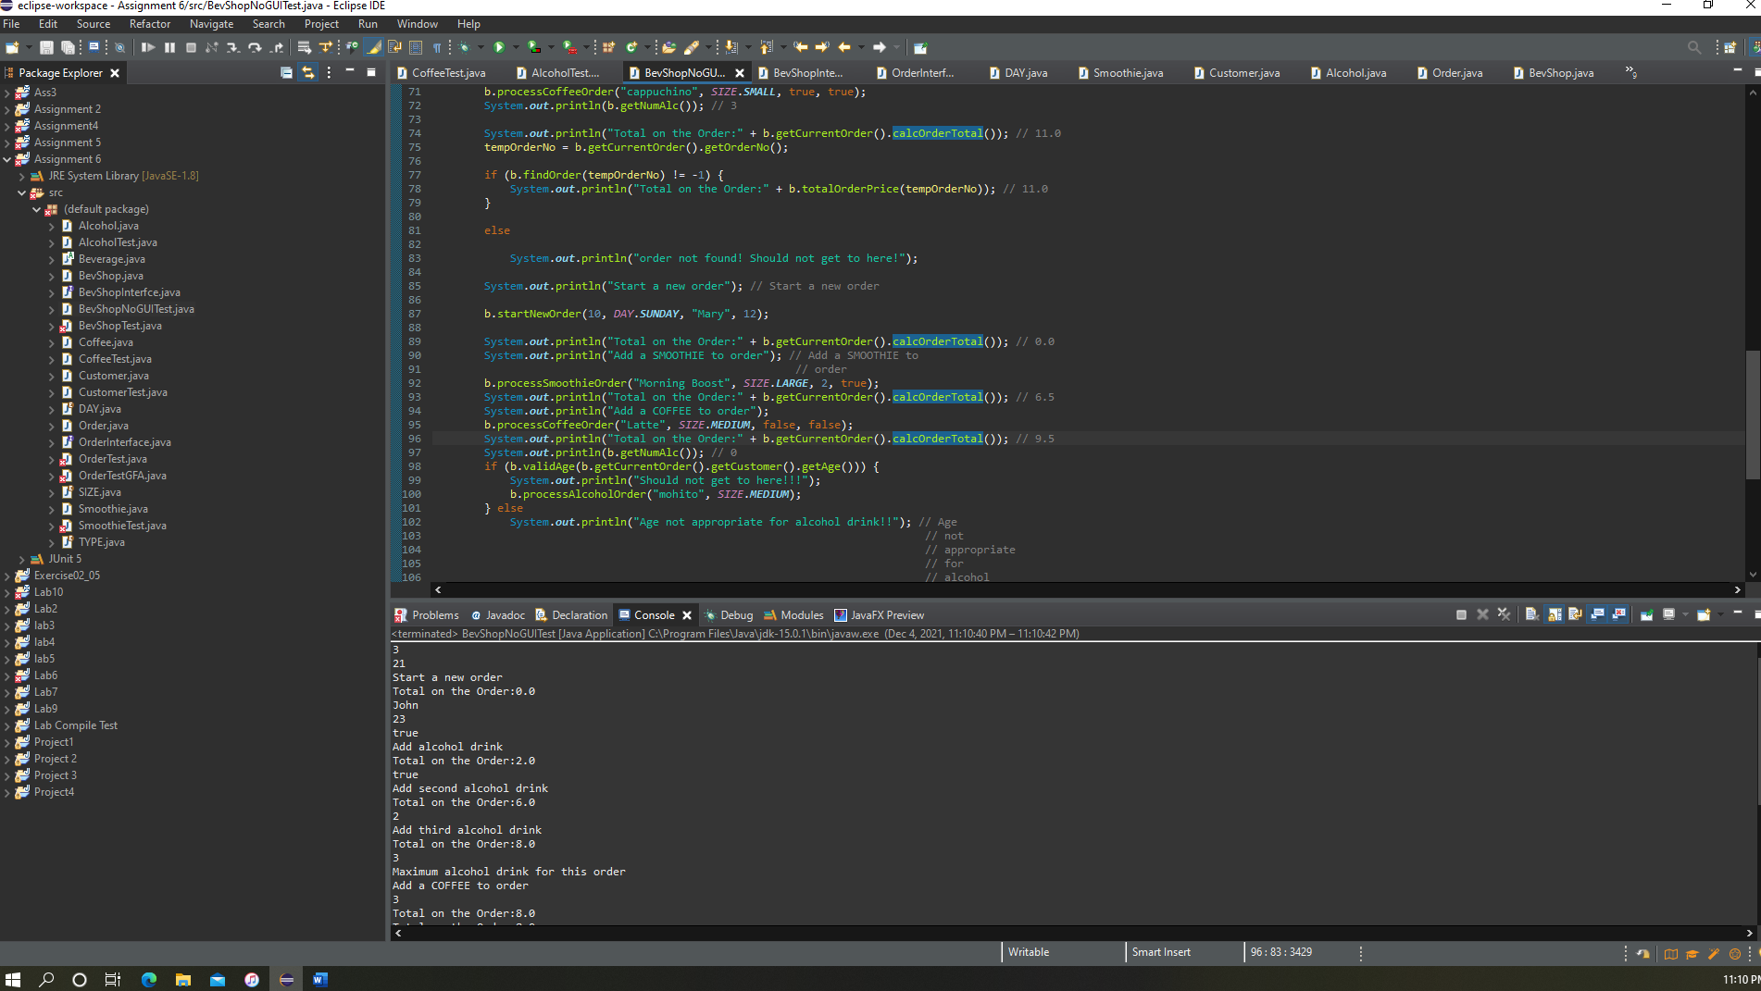

**Lessons Learned**

This assignment was the hardest of all the assignments. I actually learned a lot in this assignment about classes and inheritance. I also learned about enums. I first I couldn't figure out where to put my enums but then I made a separate class for it and it worked out. I also learned a lot about the aggregation relationship between the classes.